# MailgunStep

**Objective:**

It is used to send email to authorized recipients.

**Attributes:**

|  |  |
| --- | --- |
| **Attributes** | **Description** |
| from_name | To enter the from name |
| from_email | Used to enter the from email to send |
| to | To enter to mail address to receive the mail |
| cc | To add cc mail address |
| bcc | To add bcc mail address |
| body_type | Used to select the body type |
| subject | To enter the subject |
| value_type | To select type as free marker template or handlebar |
| body | To enter the body |
| plugin_name | Used to select the plugin name |

**Sample config.json:**

{

"workflows": [

{

"name": "mail-gun-test",

"id": "mailgun",

"trigger": "rest",

"expression": "mailgun",

"method": "GET",

"steps": [

{

"to": "rajnish@500apps.com",

"cc": "ram@500apps.com",

"bcc": "saikrishna.agilecrm@gmail.com",

"id": "1",

"type": "mailgun",

"plugin_name": "mailgun",

"value_type": "hb",

"from_name": "",

"from_email": "mailgun@500apps.com",

"body_type": "html",

"subject": "",

"body": "<b>hi rajnish kumar </b>",

"next": {

"success": "hangup",

"failure": "hangup"

}

}

]

}

],

"filters": [],

"server": {},

"plugins": [

{

"id": "11",

"apiKey": "e38f6c4b814be39962b0d1c1ac2bd77e-060550c6-3d5656e8",

"host": "sandbox473339ddd6f94bb58a6b239eb847d2eb.mailgun.org",

"type": "mailgun-plugin",

"name": "mailgun",

"version": "1.0"

}

]

}

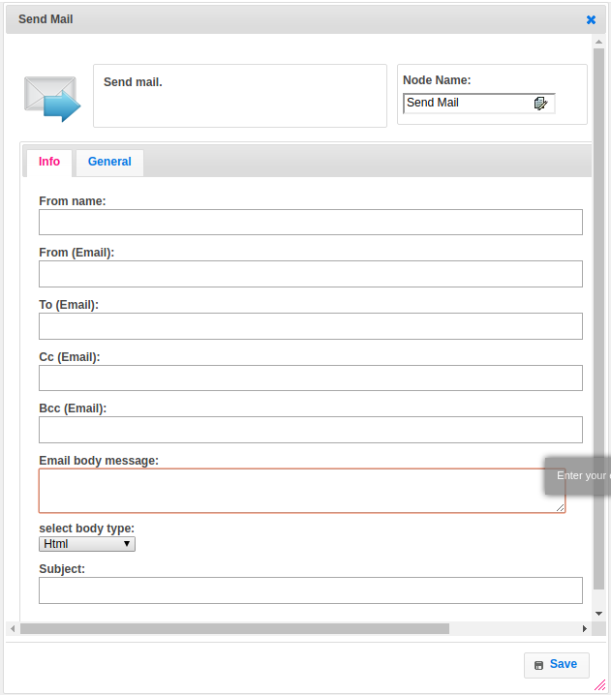

**Executor Description:**

In executor class first Return array of string by splitting given input with given delimiter, If given input is null then return empty array of strings will add from, to, cc, bcc email addresses and also subject, body adding to multipart body. Then add apiURL, multipart body object and header to okhttp3request. Call okhttp3 client and execute the request and get response.